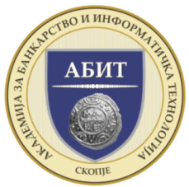

CLIENT RELATIONSHIP MANAGEMENT

Name and Surname:
Institution:
ID number:
VAT:
Position:
Phone:
e-mail :
- All fields are required
Date: 30-31, Маy, 2019 .
Location: Academy for Banking and Information Technology – ABIT (Skopje, North Macedonia)
Price: € 890 (international German/EU Certificatefor level 4 certification in Certified Branch Manager, including materials, coffee and lunch);
- 80% of participation for second participant from the same institution (€ 712)
- 50% of participation for the third participant from the same institution (€ 445)

PAYMENT DETAILS:
Heidelberg Institute Skopje
Bank: NLB Banka AD Skopje
Bank address: St. “MajkaTereza” No. 1 Skopje
IBAN: MK07210701001330263
SWIFT CODE: TUTNMK22

Academy of Banking and Information Technology
ABIT –Skopje

Bank: NLB Banka AD Skopje
Bank address: St. “MajkaTereza” No. 1 Skopje
IBAN: MK07210722000039546
SWIFT CODE: TUTNMK22
Payment: NOT later than 3 days before the beginning of the training

NOTE: The filled application send by e-mail: info@abit.edu.mk
Application deadline: At least 3 (three) days before the training

